1. Write program to find whether a given year is a leap year or not.

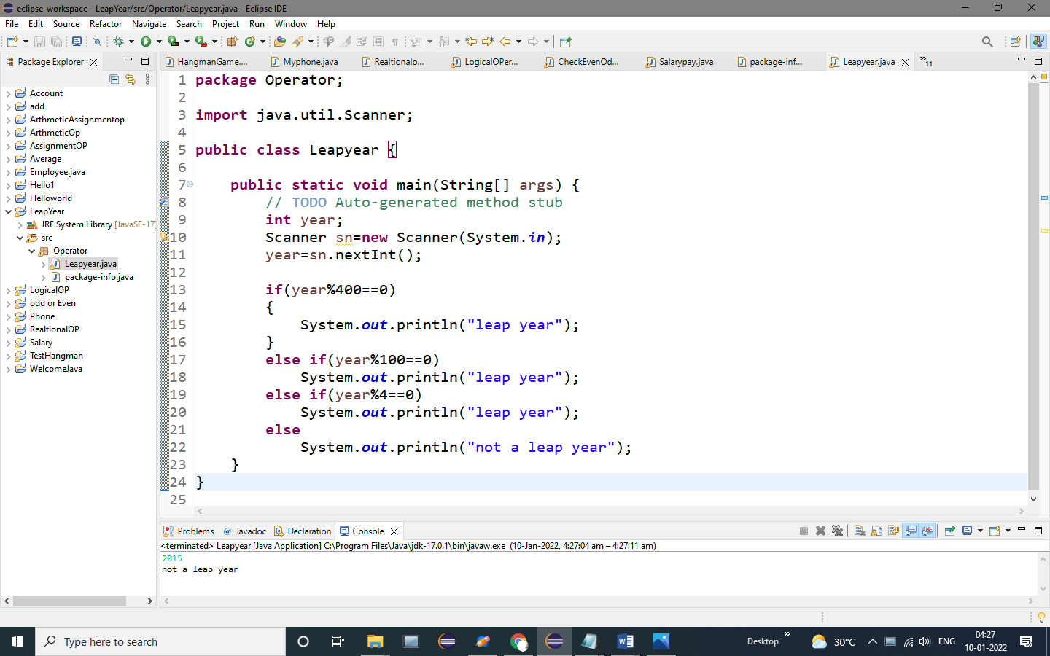

OUTPUT:

2015

Not a leap year

2. Program to check whether a character is an alphabet, digit or special character.

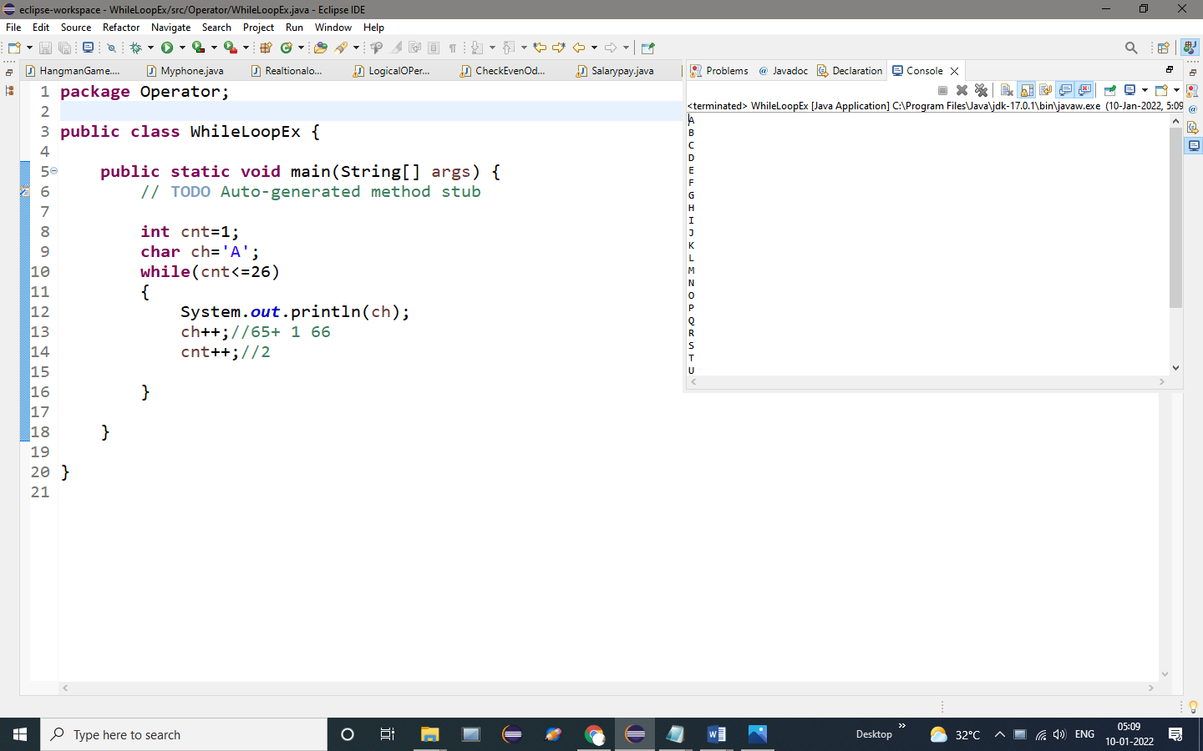

OUTPUT:

A

B

C

D

E

F

G

H

I

J

K

L

M

N

O

P

Q

R

S

T

U

V

W

X

Y

3.program to read roll no, name and marks of three subjects and calculate the total, percentage and division   
Test Data :  
Input the Roll Number of the student :784  
Input the Name of the Student :James  
Input the marks of Physics, Chemistry and Computer Application : 70 80 90  
Expected Output :  
Roll No : 784  
Name of Student : James  
Marks in Physics : 70  
Marks in Chemistry : 80  
Marks in Computer Application : 90  
Total Marks = 240  
Percentage = 80.00  
Division = First

**PROGRAM:**

**import** java.util.Scanner;

**public** **class** StudentMark {

**public** **static** **void** main(String[] args) {

// **TODO** Auto-generated method stub

**int** RollNo;

System.***out***.println("Enter the roll number: ");

Scanner s1=**new** Scanner(System.***in***);

RollNo=s1.nextInt();

System.***out***.println("Roll number: "+RollNo);//print the Rollno

String Name;

System.***out***.println("Enter the name: ");

Scanner s2=**new** Scanner(System.***in***);

Name=s2.next();

System.***out***.println("The name: "+Name);//Print the Name

**int** M1;

System.***out***.println("Enter the marks in physics: ");

Scanner s3=**new** Scanner(System.***in***);

M1=s3.nextInt();

System.***out***.println("The marks in physics: "+M1);//Print the M1 Mark

**int** M2;

System.***out***.println("Enter the marks in chemistry: ");//print the M2 data

Scanner s4=**new** Scanner(System.***in***);

M2=s4.nextInt();//assign the values to M2

System.***out***.println("The marks in chemistry: "+M2);//print the M2 values

**int** M3;

System.***out***.println("Enter the marks in C.S: ");

Scanner s5=**new** Scanner(System.***in***);

M3=s5.nextInt();//assign s5 to M3

System.***out***.println("The marks in C.S: "+M3);//print the M3

**int** total=(M1+M2+M3);//add the 3 values

System.***out***.println("The total marks: "+total);//print the total values

**float** percentage=(M1+M2+M3)*0.333f;//add & Multiply the values

System.***out***.println("The total percentage: "+percentage);//find the percentage of the total values

**if**(percentage>=80)

{

System.***out***.println("First class");//print the First class of percentage

}

**else** **if**(percentage>=60)

{

System.***out***.println("Second class");//print the second class of percentage

}

**else** **if**(percentage>=35)

{

System.***out***.println("third class");//print the Third class of percentage

}

**else**

{

System.***out***.println("fail");//print fail

}

}

}

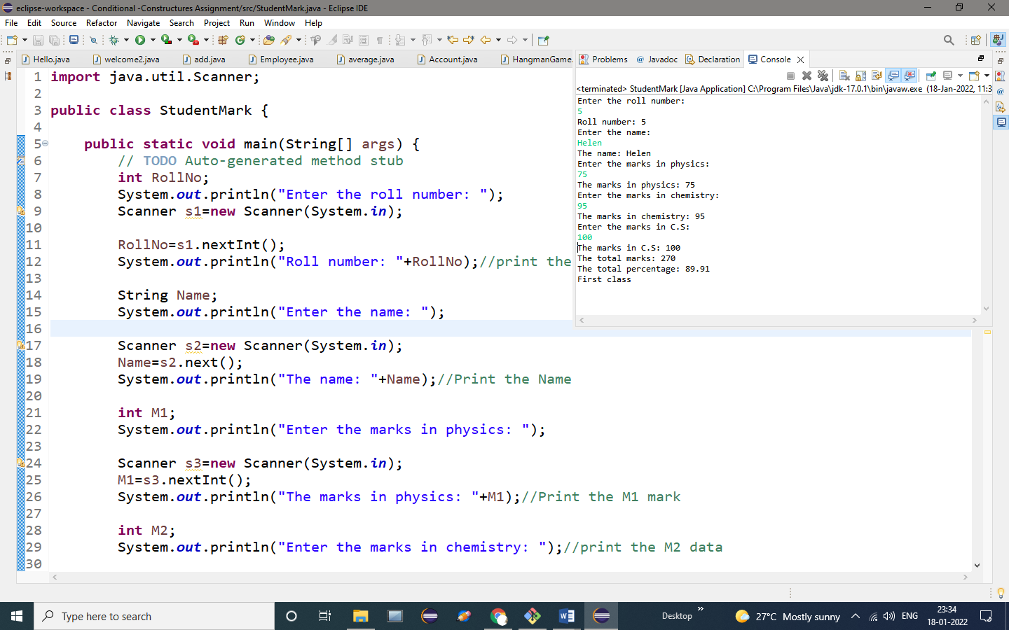

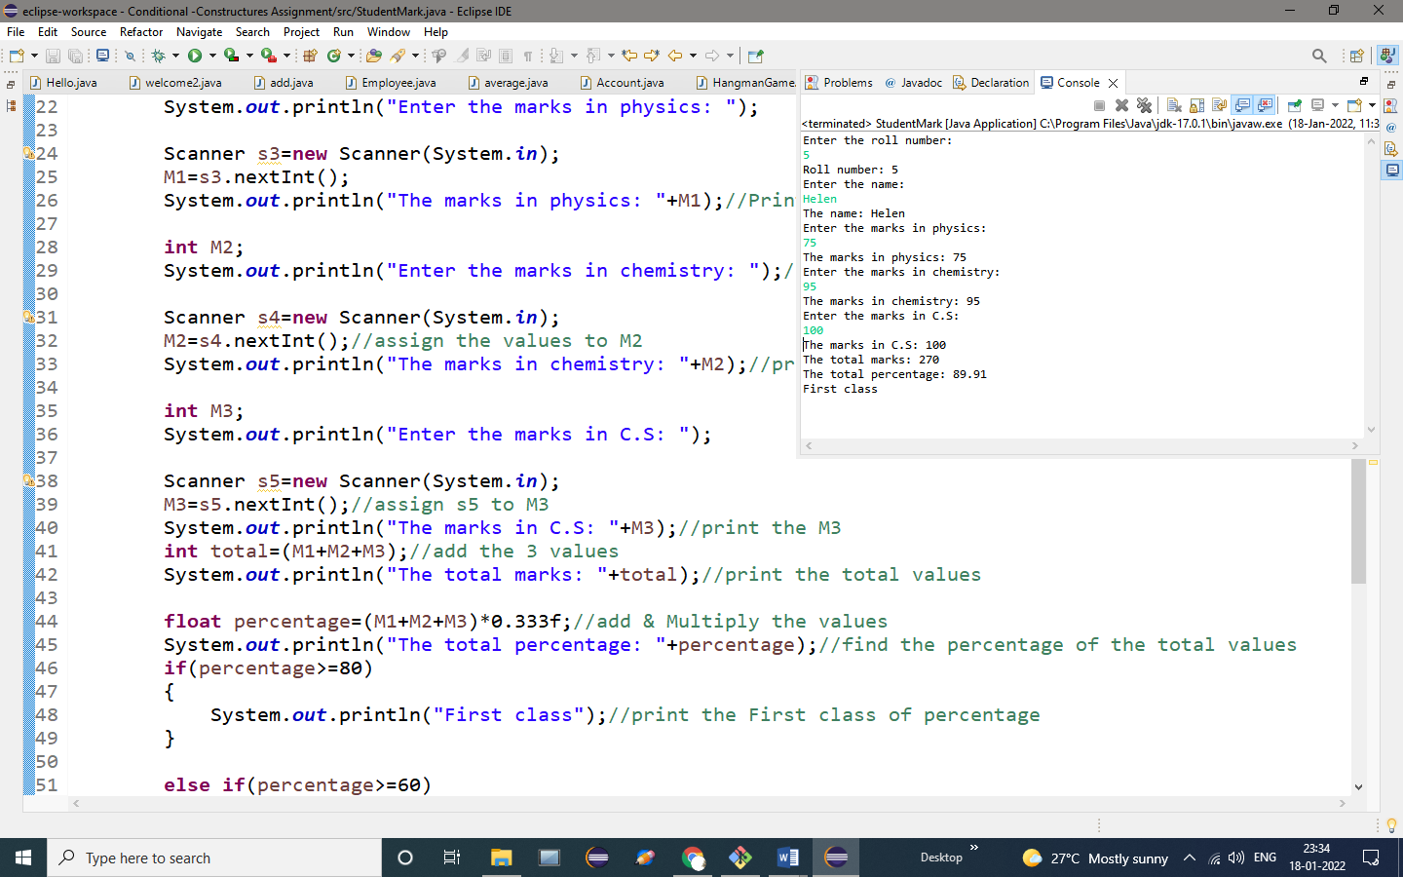

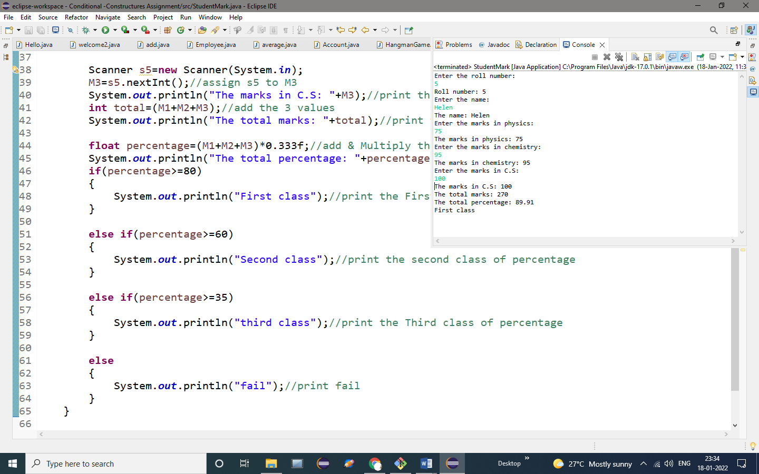

**OUTPUT:**

Enter the roll number:

5

Roll number: 5

Enter the name:

Helen

The name: Helen

Enter the marks in physics:

75

The marks in physics: 75

Enter the marks in chemistry:

95

The marks in chemistry: 95

Enter the marks in C.S:

100

The marks in C.S: 100

The total marks: 270

The total percentage: 89.91

First class

4.Program to read temperature in centigrade and display a suitable message

**PROGRAM:**

**import** java.util.Scanner;

**public** **class** Centigrade {

**public** **static** **void** main(String[] args) {

// **TODO** Auto-generated method stub

**char** ch;

System.***out***.println("enter the charector: ");

Scanner s1=**new** Scanner(System.***in***);

ch=s1.next().charAt(0);//charAt returns the char at the specific index of the string

**if**(ch>='a'&&ch<='z'||ch>='A'&&ch<='Z')//check if the ch is letter

{

System.***out***.println("Charector is an alphabet");

}

**else** **if**(ch>='0'&&ch<='9')//check if the ch is digit

{

System.***out***.println("Charector is a digit");

}

**else** **if**(ch=='!'||ch=='@'||ch=='#'||ch=='$'||ch=='%'||ch=='^'||ch=='&'||ch=='*')//check if the Ch is special Charactor

{

System.***out***.println("Charector is a special charector");

}

**else**

{

System.***out***.println("invalid"); //print invalid

}

}

}

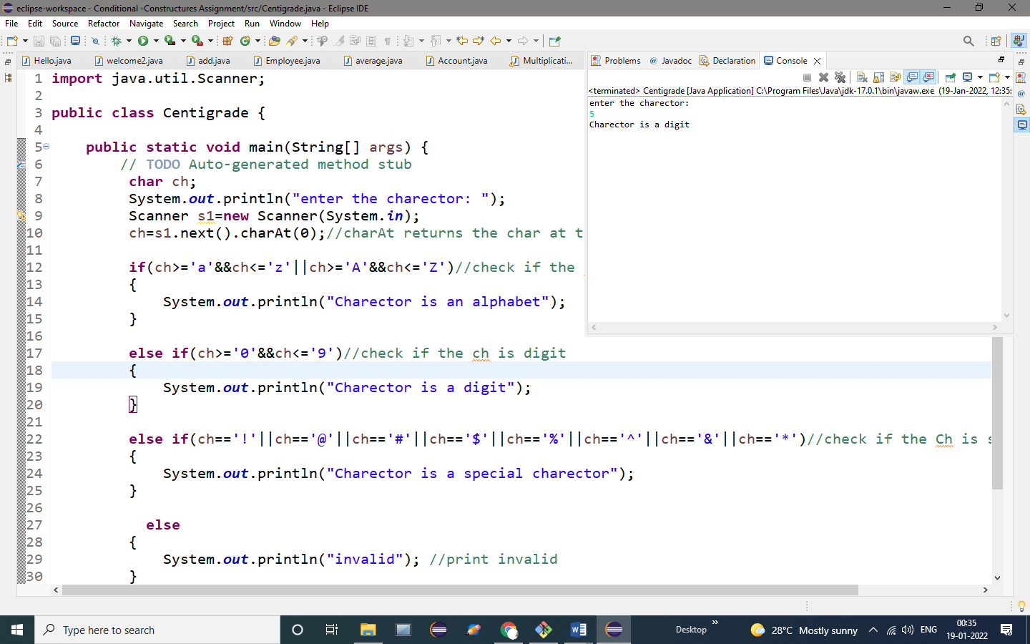

**OUTPUT:**

enter the charector:

5

Charector is a digit

5.Write a program in to accept a grade and declare the equivalent description

|  |  |
| --- | --- |
| **Grade** | **Description** |
| E | Excellent |
| V | Very Good |
| G | Good |
| A | Average |
| F | Fail |

Test Data :  
Input the grade :A  
*Expected Output* :  
You have chosen : Average

**PROGRAM:**

**import** java.util.Scanner;

**public** **class** Grade {

**public** **static** **void** main(String[] args) {

// **TODO** Auto-generated method stub

**char** ch;

System.***out***.println("enter the charector: ");

Scanner s1=**new** Scanner(System.***in***);

ch=s1.next().charAt(0);//charAt returns the char at the specific index of the string

**switch**(ch)

{

**case** 'E':System.***out***.println("Exelent");//print the char excellent

**break**;

**case** 'V':System.***out***.println("Very Good");//print the char very Good

**break**;

**case** 'G':System.***out***.println("Good");//print the char Good

**break**;

**case** 'A':System.***out***.println("Average");//print the Char Average

**break**;

**case** 'F':System.***out***.println("Fail");//print the char Fail

**break**;

**default**:System.***out***.println("invalid");//print invalid

}

}

}

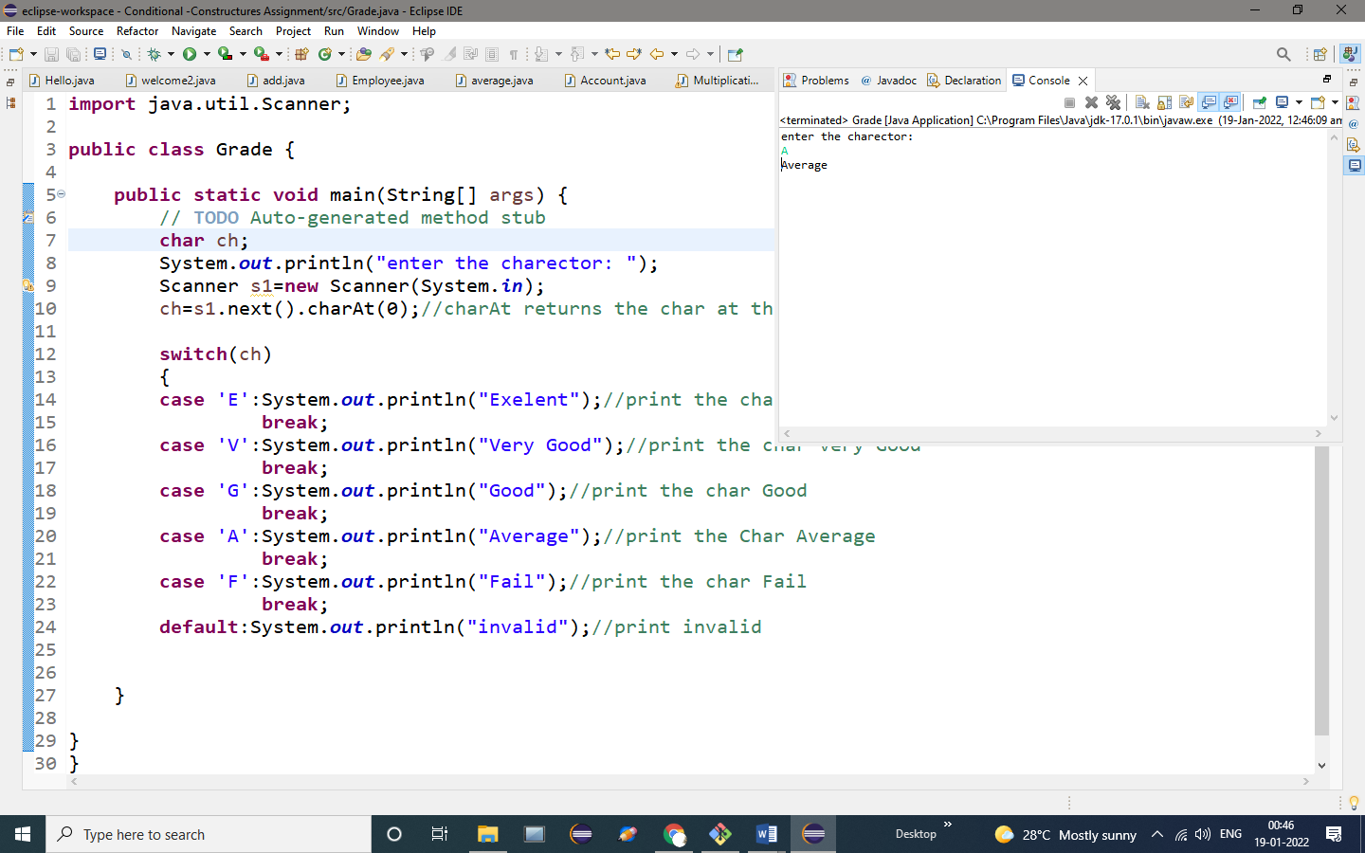

**OUTPUT:**

enter the charector:

A

Average

6. Write a program to read any day number in integer and display day name in the word.

**PROGRAM:**

**import** java.util.Scanner;

**public** **class** Day {

**public** **static** **void** main(String[] args) {

// **TODO** Auto-generated method stub

**int** a;

System.***out***.println("enter the choice: ");

Scanner s1=**new** Scanner(System.***in***);

a=s1.nextInt();

**switch**(a)

{

**case** 1:System.***out***.println("MONDAY");//print case 1 "Monday"

**break**;

**case** 2:System.***out***.println("TUESDAY");//print case 2 "Tuesday"

**break**;

**case** 3:System.***out***.println("WEDNESDAY");//print case 3 "Wednesday"

**break**;

**case** 4:System.***out***.println("THURSDAY");//print case 4 "Thursday"

**break**;

**case** 5:System.***out***.println("FRIDAY");//print case 5 "Friday"

**break**;

**case** 6:System.***out***.println("SATURDAY");//print case 6 "Saturday"

**break**;

**case** 7:System.***out***.println("SUNDAY");//print case 7 "Sunday"

**break**;

**default**:System.***out***.println("invalid");//print Invalid

}

}

}

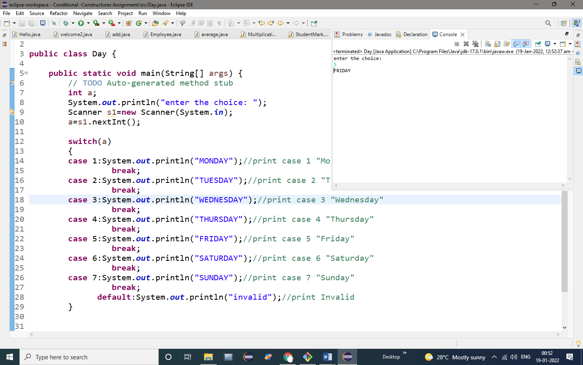

**OUTPUT:**

enter the choice:

5

FRIDAY

7.Read integer value and display the number of days for this month.

**PROGRAM:**

**import** java.util.Scanner;

**public** **class** Month {

**public** **static** **void** main(String[] args) {

// **TODO** Auto-generated method stub

String month1;

System.***out***.println("enter the month: ");

Scanner s1=**new** Scanner(System.***in***);

month1=s1.next();

**switch**(month1)

{

**case** "january":

**case** "march":

**case** "may":

**case** "july":

**case** "agust":

**case** "october":

**case** "december":System.***out***.println("31 Days");//print december

**break**;

**case** "april":

**case** "june":

**case** "september":

**case** "november":System.***out***.println("30 Days");//print november

**break**;

**case** "february":System.***out***.println("28 Days");//print februaty

**break**;

**default**:System.***out***.println("invalid"); //print invalid

}

}

}

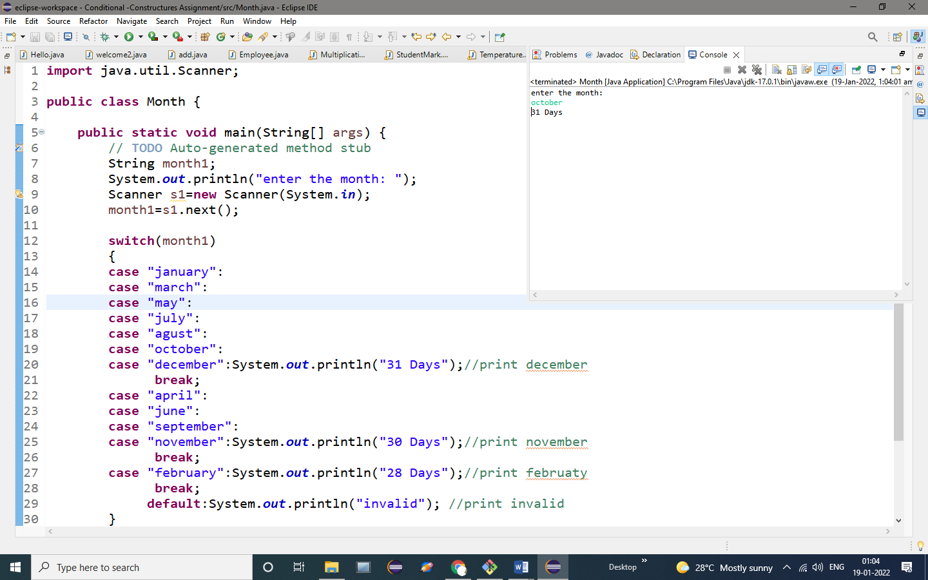

**OUTPUT:**

enter the month:

october

31 Days